**Assignment 4 Report**

**Contact Information:**

Name: Ved Ranade

Email ID: [vranade1@binghamton.edu](mailto:vranade1@binghamton.edu)

**Contents:**

1. Purpose of the Assignment
2. Method – Algorithms Used

2.1 Formula for calculating eight-point Discrete Cosine Transform

2.2 Formula for calculating eight point Inverse Discrete Cosine Transform

2.3 Formula for converting HSI to RGB

1. Running the program
2. Results
3. Bug Report
4. **Purpose of the Assignment:**

The purpose of completing this assignment is to understand morphological operations and their applications in image processing:

* Program description language
* Structuring elements
* Dilation and erosion
* Opening and closing
* Hit and miss operation

**2. Method - Algorithms Used:**

2.1 Performing dilation operation:

Structuring elements used:

S1 = [1,1,1, S2 = [1,1,1,1,1,

1,1,1, 1,1,1,1,1,

1,1,1] 1,1,1,1,1,

1,1,1,1,1,

1,1,1,1,1]

In each of the structuring elements, the origin is the element at the center. The larger the structuring element, greater is the degree of dilation achieved.

Steps:

* Move the structuring element over the image such that the origin of the structuring element overlaps with each pixel in the image.
* At a particular position of the structuring element, calculate the product of each element in the structuring element with the corresponding pixel in the image and store it in a linear array.
* Find out the maximum value in the linear array and assign that value to the pixel in the image which is overlapped by the origin of the structuring element.

This algorithm works for both grayscale images as well as binary images.

2.2 Performing erosion operation:

Structuring elements used:

S1 = [1,1,1, S2 = [1,1,1,1,1,

1,1,1, 1,1,1,1,1,

1,1,1] 1,1,1,1,1,

1,1,1,1,1,

1,1,1,1,1]

In each of the structuring elements, the origin is the element at the center. The larger the structuring element, greater is the degree of erosion achieved.

Steps:

* Move the structuring element over the image such that the origin of the structuring element overlaps with each pixel in the image.
* At a particular position of the structuring element, calculate the product of each element in the structuring element with the corresponding pixel in the image and store it in a linear array.
* Find out the minimum value in the linear array and assign that value to the pixel in the image which is overlapped by the origin of the structuring element.

This algorithm works for both grayscale images as well as binary images.

2.3 Performing opening operation:

Steps:

* Perform erosion operation on image
* Perform opening operation on the eroded image

2.4 Performing closing operation:

Steps:

* Perform opening operation on image
* Perform closing operation on the opened image

2.4 Custom method for separating objects in the given image:

Steps:

* Convert the greyscale image to binary image using basic global thresholding
* Apply the erosion operation three times on the binary image using the 5x5 structuring element
* Apply the dilation operation once on the eroded image using the 3x3 structuring element to separate the objects (pigs).

1. **Running the program:**

***OpenCV version 3.3 was used for the execution of this assignment***

Step 1: Unzip the uploaded files to a location

Step 2: Find and run the file named Assignment4.exe in the extracted directory

Step 3: The application window will come up. Select the drop down tab named ‘Process’ to run the different morphological operations

1. **Results**

Input Image:



Binary Image F:



Morphological operations on binary image F:

Dilation:

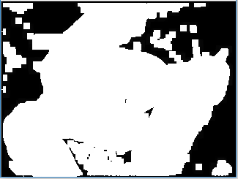

Erosion:

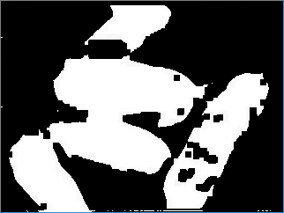

Opening:

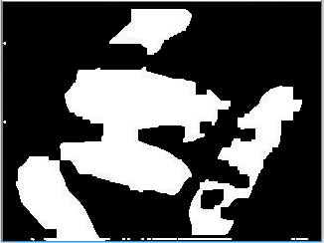

Closing:

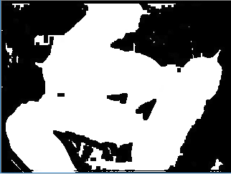

Morphological operations on greyscale image:

Dilation:

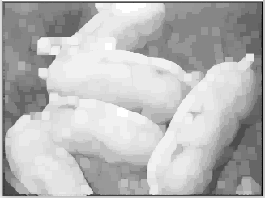

Erosion:

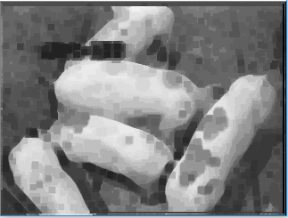

Opening:

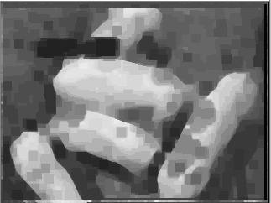

Closing:

